**ANALYST LEAGUE HR ATTRITION ANALYSIS**



**Introduction:**In any employment setting, employee satisfaction and happiness is a key factor in maintaining a productive and motivated workforce.  
This report aims to analyze factors that contribute to employee turnover.

**Objectives:**· To analyze HR data for insights on employee demographics, attrition rates, employee wellness  
· Assess the effectiveness of company policies, training  
· Visualize findings

**Dashboard**

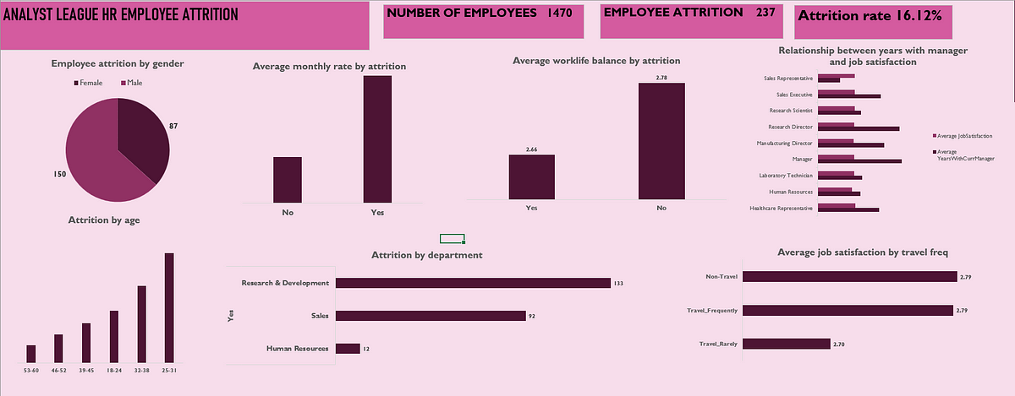

**Insights and Recommendations**1. Attrition rates within departments:

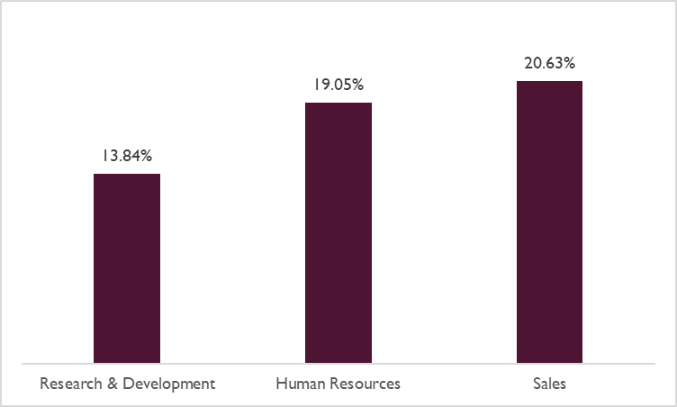

Research and development has the lowest attrition rate followed by Human resources, with Sales having the highest.

2. How does job satisfaction differ between departments?

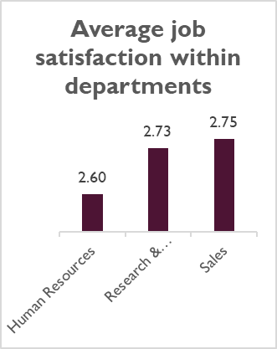

Sales department has the highest average job satisfaction(2.75) with Human Resources having the least(2.60)  
To improve job satisfaction:  
•Offer flexible work schedules  
•Encourage work-life balance  
•Recognise job performance

3. Effects of distance on employee satisfaction and turnover:

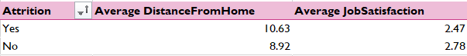

The table above shows that employees who left the company lived an average of 1.7km farther away from the office than those who stayed, causing a lesser average job satisfaction.  
Providing flexible work arrangements like remote/hybrid work, flexible hours could reduce the rate of attrition caused by lengthy commute.

4. Impact of working overtime on work-life balance:

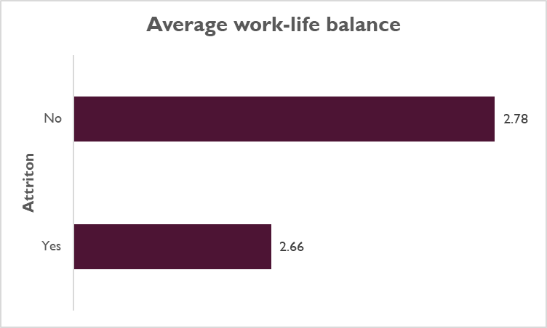

We can see that staff who left the company have a lesser work-life balance compared to those who stayed.

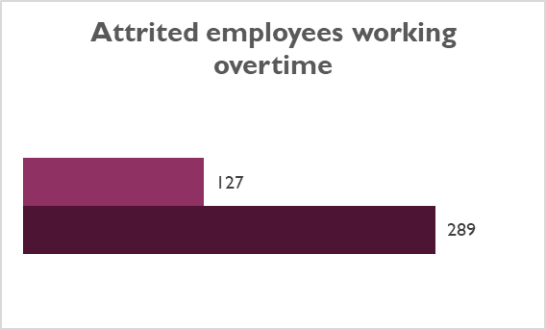

We can also that out of the 289 employees who left, 127(43.94%) worked overtime, reducing their work-life balance.

5. Comparing amount of training in various job roles to job performance:

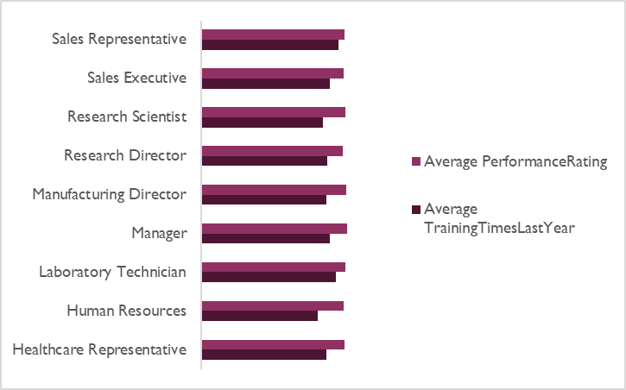5

Within job roles, the average performance rating is significantly higher when compared with the amount of training undergone.  
This goes on show the efficiency of the training programs. These training can be further optimised through continuous feedback, tailored trainings, whilst tracking the impacts of these programs.

6. Stock option level vs. Attrition

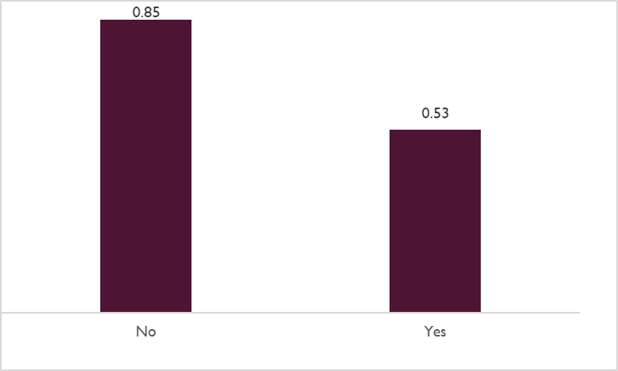

Employees who left the company have a lower stock of option level, an average difference of 0.32 when compared to those who stayed.

**Conclusion**

Key factors that contributed to employee attrition include:  
· Poor work-life balance caused by excessive overtime and long commute

· Lower stock option level

· Departmental differences

To address these issues and improve employee retention:  
· Prioritize work-life balance

· Address commute issues

· Review and adjust compensation plans for employees